Bedwas, Trethomas & Machen Community Council
Environment (Wales) Act 2016
Biodiversity Duty Plan 2026

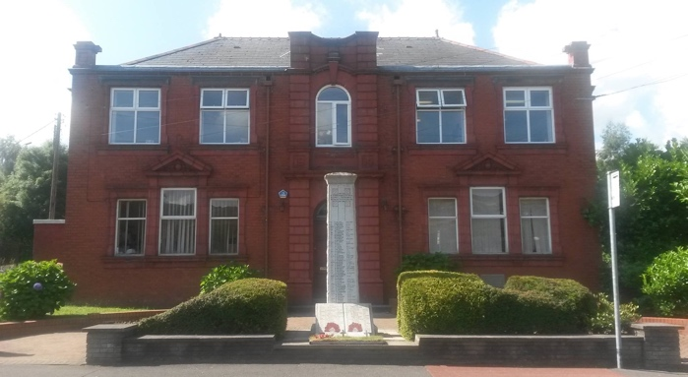 |  | 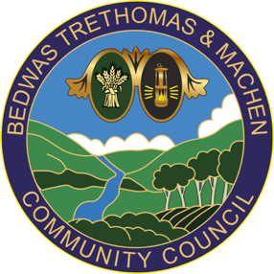
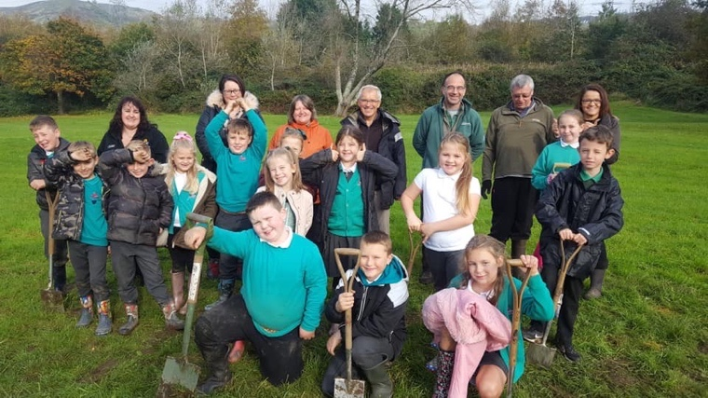 |  | 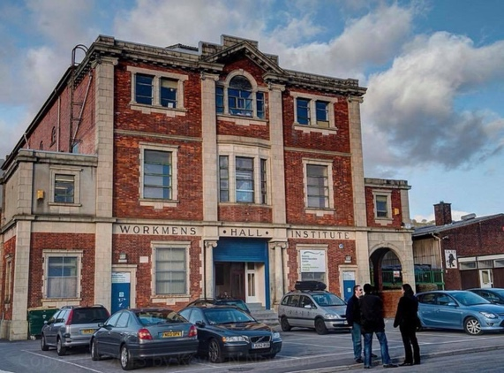
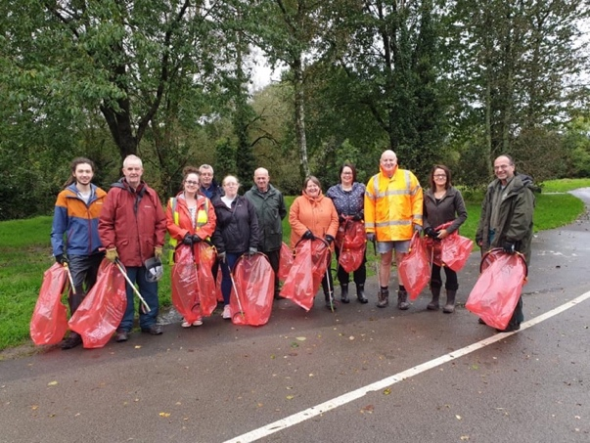 |  | 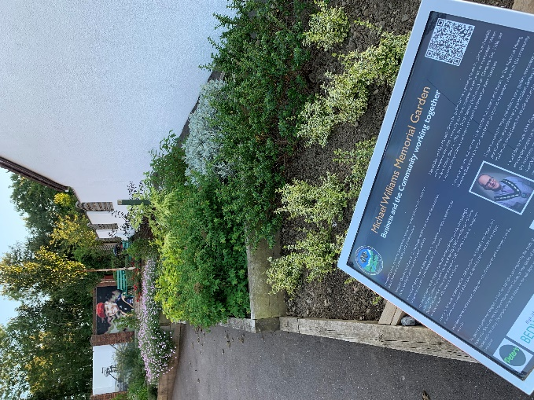
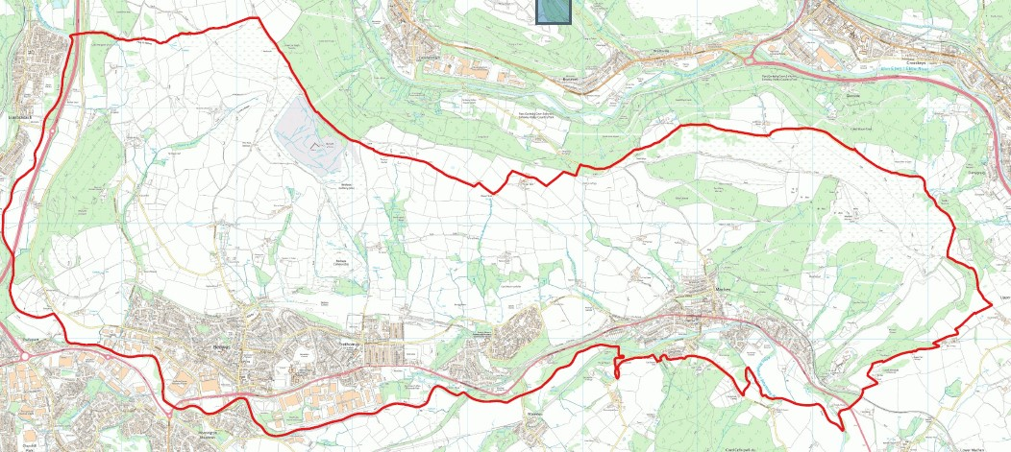

Bedwas, Trethomas, Machen & Graig y Rhacca
Biodiversity Duty Plan - 2023

Contents

Executive Summary.............................................................. 3

Introduction......................................................................... 4

Legislative Framework...................................................... 4

Bedwas Trethomas and Machen Community Council
Biodiversity Duty Plan and principles................................................... 6

Natural Resources in BTM and Graig Y Rhacca........................................ 7

Biodiversity Actions 2023 – 2026 ........................................................... 8

EXECUTIVE SUMMARY

Bedwas, Trethomas and Machen (BTM) Community Council has a legal duty to maintain and enhance biodiversity and in so doing promote the resilience of ecosystems under the Environment (Wales) Act 2016. This plan demonstrates how we will fulfil that duty and will act as a driver for ensuring that all service areas consider biodiversity and actively enhance biodiversity when carrying out our day-to-day activities.

BTM Community Council will work with Caerphilly County Borough Council to promote and develop an Action Plan within the Bedwas, Trethomas and Machen areas.

The Welsh Government has introduced a number of new legislative requirements for public bodies and local authorities to comply with, which will change the way services are planned and delivered through the principle of sustainable development. The County Biodiversity Duty Plan is underpinned by local ward plans in which each area explains how ward based services recognise and demonstrate local actions.

The BTM plan will be revised at least every three years and will underpin the County Plan which will be formally reported to Welsh Government by early 2026 and every three years thereafter.

Principally, this Plan builds on the intelligence of former county biodiversity action plans, highlights the connections between the Wellbeing of Future Generations (Wales) Act, county actions through the Nature Recovery Plan for Wales and helps the Community Council to plan and deliver its local services clearly with sustainable development at its centre.

BTM enjoys rich and diverse habitats with some notable sites of importance for nature conservation (SINC). In order to enhance or maintain our valued natural (and build) assets, our biodiversity actions are listed in the Plan and include:

- partnering with experts and local organisations
- using resources wisely and where there is positive impact on biodiversity and environment
- examining our own behaviour and making changes to reduce our footprint and promote good practice within our community.

This Plan is our first and will develop over time as we understand more about the duties and monitoring/reporting which is required. We have produced it in two sections. The first being recognition of our duty and the second, the action plan which will remain in development and reported on as a live document. This will be our local response to emerging issues and ideas.

INTRODUCTION
This plan has been prepared as part of the Council’s legal obligation as set out in the Environment (Wales) Act 2016. All public bodies must seek to maintain and enhance biodiversity in the exercise of their functions. As a first step, the Council (as other public bodies) are required to prepare and publish a plan on how they intend to comply with its “biodiversity and resilience of ecosystems Duty”.

Interim guidance published by Welsh Government sets out that public authorities must take into account relevant evidence when complying with the Section 6 duty of the Environment Act including the State of Natural Resources Report published by NRW, 2016, the Environment (Wales) Act 2016, Section 7 lists of habitats and species of principal importance in Wales, and relevant Area Statements to be prepared by Natural Resources Wales under Section 11 of the Act. More detailed guidance from Welsh Government on this plan has not been finalised. In the interim, this plan’s actions have been drawn up in line with the objectives in the Nature Recovery Plan. At the same time, those actions allocated to the authority in the Nature Recovery Plan are incorporated into this plan.

In this plan the Council:
- Explains the legislative background to this report and the multiple benefits resulting from the proposed actions
- Outlines the natural resources in Bedwas, Trethomas, Machen and Graig y Rhacca; identify why they are so special and summarise what has already been done to protect them;
- Set out how the forward plan works and the mechanisms for delivery and
- Gives detailed actions to be achieved with milestones for reporting.

LEGISLATIVE FRAMEWORK

ENVIRONMENT (WALES) ACT 2016
The Environment (Wales) Act became law on the 21st March 2016. It puts in place legislation to enable Wales’ resources to be managed in a more proactive, sustainable and joined up way and to establish the legislative framework necessary to tackle climate change. The Act supports the Welsh Government’s wider remit under the Well-being of Future Generations (Wales) Act 2015, so that Wales benefits from a prosperous economy, a healthy and resilient environment and vibrant, cohesive communities.

Specifically, the Act places an enhanced biodiversity duty on public authorities (appendix A)

Section 6(1) - A public authority must seek to maintain and enhance biodiversity in the exercise of functions in relation to Wales, and in doing so promote the resilience of ecosystems, so far as Is consistent with the proper exercise of those functions

The intention of this duty is to ensure biodiversity becomes an integral part of decision making in public authorities. The duty came into force in May 2016.

Unlike previous provision, the new duty requires formal demonstration of compliance. The authority is therefore required by the Act to prepare and publish a plan setting out how it intends to comply with the duty. While the Act does not set a timescale for this, guidance from Welsh Government encouraged its production in 2017. The Act requires public bodies to publish a report by the end of 2019 on what it has done to comply with the duty which is then required to be reported on every 3 years thereafter.
The Act also requires Natural Resources Wales (NRW) to publish a State of Natural Resources Report setting out the current status of natural resources in Wales. The local authority is required to have regard to the findings of this report in exercising its functions. Local issues and matters of importance will be obtained to assist in writing a ward level plan.

WELL-BEING OF FUTURE GENERATIONS (WALES) ACT 2015
The Well-being of Future Generations (Wales) Act 2015 is about improving the social, economic, environmental and cultural well-being of Wales. It set out ways of working that ensure all elements of well-being are considered together and encouraged collaborative working.

The Act placed a duty on public bodies to carry out actions towards sustainable development. This is defined as a process of improving the economic, social, environmental and cultural wellbeing of Wales. This is achieved through taking action in accordance with the sustainable development principle so that well-being goals are achieved.

The 7 well-being goals identified within the Act, were incorporated into a Well-being Plan in Caerphilly County Borough Council working with the Public Service Board and other statutory organisations to provide Well-being Objectives.

Any plan/project must demonstrate working practices to meet the Well-being of Future Generations Act. The County Biodiversity Duty Plan will meet each one:

NATURE RECOVERY PLAN FOR WALES
The Nature Recovery Plan for Wales (2015) recognises that the importance of biodiversity as underpinning healthy functioning ecosystems, human well-being and the economy. The Plan builds on the legislative frameworks set out above and identifies how, in Wales, we can address underlying causes of biodiversity loss. Specifically by:

- Putting nature at the heart of decision-making
- Increasing the resilience of our natural environment
- Taking specific action for habitats and species.

It sets out how Wales will deliver the commitments of the Convention on Biological Diversity and the EU Biodiversity Strategy to halt the decline of our biodiversity by 2020 and then reverse that decline. The ambition of the plan is:

To reverse the decline in biodiversity, for its intrinsic value, and to ensure lasting benefits to society

Part 1 of the Nature Recovery Plan sets out the objectives needed in Wales to achieve the ambition:

- Engage and support participation and understanding to embed biodiversity throughout decision making at all levels
- Safeguard species and habitats of principal importance and improve their management
- Increase the resilience of our natural environments by restoring degraded habitats and habitat creation
- Tackle key pressures on species and habitats
- Improve evidence, understanding and monitoring
- Put in place to framework of governance and support for delivery

Part 2 of the Nature Recovery Plan sets out an action plan. A number of actions are allocated to the local authority as a key partner for delivery which will be incorporated into the Biodiversity Duty Plan.

CAERPHILLY COUNTY BOROUGH BIODIVERSITY ACTION PLANS
A partnership approach to biodiversity has been the approach Caerphilly County Borough Council has taken since the early 2000s. In this, environmental organisations, the Local Authority and community organisations have identified the habitats and natural resources within the County Borough and, over the years, have taken steps to increase the diversity and quality of biodiversity through a number of action plans. The habitats and species statements within those action plans have identified a number of notable assets which are located within the BTM ward. This Environmental Plan will seek to build on the intelligence already gathered and continue to work in partnership with relevant bodies to protect and enhance biodiversity within the Ward.

As outlined above, CCBC now organises its key priorities and objectives for nature through the Biodiversity Duty Plan into which BTM Duty Plan sits.

BEDWAS, TRETHOMAS & MACHEN COMMUNITY COUNCIL

BIODIVERSITY DUTY PLAN and PRINCIPLES
The Biodiversity Duty Actions set out below broadly identify what local authorities intend to do to meet their legal requirements. The actions are organised into five Nature Recovery Plan objectives each of which are interdependent with other objectives. The actions currently being undertaken by CCBC in order to comply with the previous biodiversity duty have also been incorporated into their current plan. BTM will underpin its own actions through the five objectives identified through the Nature Recovery Plan for Wales - which means in practice:

Objective | BTM approach
Objective 1 - Engage and support participation and understanding to embed biodiversity through decision making at all levels | Grants panels, CIL monies and other decision-making regarding use of resources will prioritise those with most benefit towards biodiversity and the environment.
Objective 2 - Safeguard species and habitats of principal importance and improve their management | Where there are principally important species identified locally, these will be incorporated into the Council plan and appropriate actions and partners found to support management
Objective 3 - Increase the resilience of our natural environments by restoring degraded habitats and habitat creation | The Council will use its resources towards restoring and creating habitats and will ensure that resource use increases the potential for resilience of the ward’s natural environment.
Objective 4 - Tackle key pressures on species and habitats | Where there pressured species and habitats are identified, BTM Council will seek to support relevant organisations to help mitigate risks of decline.
Objective 5 - Improve our evidence, understanding and monitoring | BTM will seek to learn more about, understand and mitigate risks around environmental pressures in the ward – within its resources and capabilities.

https://www.biodiversitywales.org.uk/Environment-Wales-Act

NATURAL RESOURCES IN BEDWAS, TRETHOMAS, MACHEN & GRAIG Y RHACCA
Priority habitats and species have been identified by the Welsh Government as required by Section 42 of the Natural Environment and Rural Communities Act 2006 and subsequently by Section 7 of the Environment (Wales) Act. A revised list of Habitats and Species of Principal Importance for the Conservation of Biological Diversity in Wales was published by Welsh Government in 2009. The list contains 51 priority habitats. This is the definitive reference for all statutory and non-statutory bodies involved in biodiversity conservation in Wales.

This plan has been produced to fulfil BTM Community Council’s legal obligation set out in the Environment (Wales) Act 201 as public bodies seek to maintain and enhance biodiversity in the exercise of their functions. This plan illustrates the Council’s intent to behave responsibly and examine its own ecological footprint with a view to making positive change in the locality.

The ward, BTM, is situated in the Caerphilly Basin area which is to the south of the County of Caerphilly. It has a resident population of over 10.7k and its main routeway linking the area is the A468. The natural habitats of the ward, included in current and previous County Biodiversity Action Plans include:

Habitat |  | Location / Description | Associated Species
Wetlands and watercourses |  | Rhymney River  Nant y Ceisiad  Redbrook streams and other tributaries  Machen pond | Grayling, salmon, brown and rainbow trout, stickleback, dace, roach, minnow, common eel, mink, otter, water vole
Deciduous Woodland |  | Machen Woodland | Green woodpecker, barn owl, pipistrelle bat, bluebell
Planted Coniferous Forest |  | Mynydd Machen but mostly now this has been felled.
Wildlife Corridors | SINC | National Cycleroute  Disused railway – Forge Way, Machen to Caerphilly  Roadside verges  Old stone walls  Farmland throughout the Ward | tree sparrow bullfinch song thrush redstart, green woodpecker, barn owl, buzzard, chaffinch · pipistrelle, brown long-eared, greater horseshoe and lesser horseshoe bats, dormouse fox, wood mouse, harvest mouse, field vole, common frog, common toad common lizard, slow worm, grass snake, dragonflies, moths (buttoned snout*) and butterflies,: cowslip, bluebell, yellow rattle, lichens and ferns  disused quarry at Machen with 4ha broadleaved woodland, it is naturally colonised, with associated pedunculate oak woodland containing ash, alder, birch and a well-developed shrub layer. Rich ground flora containing bluebells, wood anemone, dog's mercury, golden saxifrage, and lesser celandine
Common Land | SINC | Mynydd Machen  Trethomas - Machen
Species Rich Grasslands  Calcareous grassland | SINC | Graig y Rhacca acid grassland  Mynydd Machen
Post – Industrial Land colliery tips, former refuse tips, quarries | SINC  SINC | Bedwas Colliery Tip  Machen disused quarry (Tudor Gardens)  Machen disused railway pasture  Cycleroute  Bryngwyn, Bedwas  Hanson Machen limestone Quarry
Urban Habitats  Churchyards,  Parks and play areas  allotments |  | Bryn Park  Bedwas Park  Bedwas allotments  Glyn gwyn street allotments  Machen allotments
Ffridd/Coedcae |  | Western edges of Mynydd Machen  Graig y Rhacca grassland | nightjar, linnet, yellowhammer, curlew, skylark, whinchat, tree pipit and stonechat, high brown fritillary, pearl-bordered fritillary, small pearlbordered fritillary bluebell, violets
Underpinned by responsible actions in the duties and undertaking of the Council by its Councillors and employees.

During the last 50 years, there has been a dramatic loss nationally and globally in the abundance and variety of species. This is said to be linked to the changes in our modern lifestyles and the resultant demand and threats on our natural resources. Locally, we are aware of lower impact examples of habitat decline and species loss but. BTM retains a good level of rich wildlife which has evolved through changing agricultural and forestry practices, and urban and industrial developments, which have shaped the landscape of the Ward.

Welsh Government has selected the status of priority habitats and species as a headline indicator, providing a measure of national progress towards sustainable development. Future development in BTM will play a key role in ensuring that the status of priority habitats and species is improving.

The ecosystem approach is a strategy for the integrated management of land, water and living resources that promotes conservation and sustainable use in an equitable way. This is widely recognised as the international best practice for addressing the decline in biodiversity.

Ecosystem services are:
Supporting - underpins all other services and includes nutrient cycling, soil formation and primary production
Provisioning - all our food, fresh water, wood and fibre, fuel
Regulating -cleaning air and water, flood control, carbon sequestration
Cultural - aesthetic, spiritual educational, recreational

BIODIVERSITY ACTIONS 2026-2029
Habitat |  | Habitats and Species | Current and Previous Actions | Planned Action/ Target | Date for completion | By Whom
Wetlands and watercourses  streams and tributaries |  | Rhymney River | KWT voluntary river care group management | Actively support River care clean ups, walks and community actions along water courses in the ward. | Ongoing throughout the year
Wetlands and watercourses  streams and tributaries |  | Nant y Ceisiad | none | Observation as part of rainwater run off through Machen
Wetlands and watercourses  streams and tributaries |  | Redbrook wood and stream | Litter picking and clean up walks | Continue to do seasonal clear up and walks, promoting the value of natural assets | Ongoing
Wetlands and watercourses  streams and tributaries |  | Machen pond
Deciduous Woodland |  | Machen Deciduous Woodland |  | Support community initiatives to clean up or enhance the area
Planted Coniferous Forest | SINC | Mynydd Machen | Mostly managed by Forestry Commission but now largely felled | ?
Wildlife Corridors |  | National Cycle route | Litter picking and clean up walks;  Promotion of good behaviour regarding dog walking and community safety | Prioritise environmentally friendly actions as part of CIL and community grants processes.
Wildlife Corridors |  | Allotments – Glyn Gwyn st  Bedwas  Machen | ? | ?
Wildlife Corridors |  | Allotments – Glyn Gwyn st  Bedwas  Machen | ? | ?
Wildlife Corridors |  | Allotments – Glyn Gwyn st  Bedwas  Machen | ? | ?
Wildlife Corridors |  | Church yards | Supported the start of the restoration project for St John’s Machen | Continue to identify opportunities to support the Church restoration fund
Wildlife Corridors |  | Farmland throughout ward
Common Land | SINC | Mynydd Machen
Common Land | SINC | Trethomas – Machen
Species Rich Grasslands |  | Graig y Rhacca acid grassland | Bulb and tree planting as part of community engagement projects | Continue to seek opportunities to enhance the natural assets through community engagement and activities.
Fridd/Coedcae |  | Western edges of Mynydd Machen
Heathland |  | Graig y Rhacca grassland | See above | See above
Post – Industrial Land | SINC  SINC | Bedwas Colliery Tip
Post – Industrial Land | SINC  SINC | Machen disused quarry (Tudor Gardens)
Post – Industrial Land | SINC  SINC | National Cycle Route | See above | See above
Post – Industrial Land | SINC  SINC | Bryn Gwyn, Bedwas
Post – Industrial Land | SINC  SINC | Hanson Limestone Quarry Machen
Urban Habitats |  | Bryn Park
Urban Habitats |  | Bedwas Park
Urban Habitats |  | BTM Memorial Garden | Working with KWT and other partners develop the site
BTM Council commitments and behaviour |  | Reduce the need for Single use plastics and improve responsibility towards reduce, re-use and recycle attitude within the Council. | Support Plastic Free Caerphilly; plastic free lead councillor agreed  Purchased tablets to reduce paper usage and waste in Council business | Make at least three changes and partner Caerphilly initiatives.  Carry out plastic use audit for council business and councillor own households
BTM Council commitments and behaviour |  | Prioritise CIL projects which promote and enhance biodiversity | Establish CIL sub-committee | Consider adding additional environmental good practice criteria to grants and CIL decision-making.
BTM Council commitments and behaviour |  | Act as a good partner with environmental and other organisations in community initiatives which promote and enhance the environment | WHQS walk about and engagement with CCBC to identify community initiatives Established good relationships with Groundwork, KWT, allotments association and others | Invite interest and ideas from residents through newsletters and noticeboards  Conduct a biodiversity questionnaire with partners to identify current habitats / species under pressure and build up an events calendar to increase knowledge and understanding of the problem.

https://www.caerphilly.gov.uk/CaerphillyDocs/Planning/Biodiversity-Action-Plan-Caerphilly-County-Borough.aspx
http://www.cbd.int/ecosystem/

