Bedwas, Trethomas & Machen  Community Council  Ann Birkinshaw  Clerk to the Council | Please reply:  Council Offices  Newport Road  Bedwas  Caerphilly  CF83 8YB  Tel: 029 2088 5734  E-mail: clerk@btmcc.co.uk
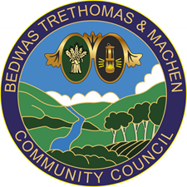

Notice of Casual vacancy

Bedwas Trethomas & Machen Community Council - Trethomas Ward

Notice is hereby given that a casual vacancy has arisen in the office of Councillor for the Community Council.

In accordance with Section 89(3) of the Local Government Act 1972, where the vacancy occurs within six months before the day on which the councillor whose office is vacant would regularly have retired, an election shall not be held under Section 89(1) of the above Act, and the vacancy will be filled at the next ordinary election of Councillors on 5th May,2022.

The Council may choose to fill the vacancy for the period until that election.

Dated: 24th February 2022

Ann Birkinshaw
Clerk/RFO to BTM CC

