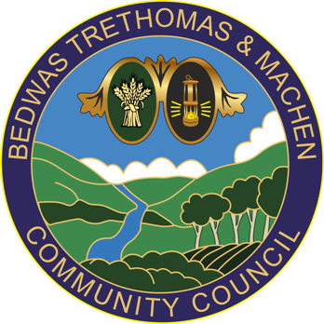
Bedwas, Trethomas & Machen Community Council
Council Offices
Newport Road
Bedwas
Caerphilly
CF83 8YB
Tel: (029) 2088 5734
E-mail: clerk@btmcc.co.uk

17th January 2022

To: All Councillors of Bedwas, Trethomas & Machen Community Council

You are summoned to attend an ‘EXTRAORDINARY MEETING’ via Microsoft Teams on Wednesday 26th January 2022 at 6:00pm. The MS Teams link to follow.

If you are unable to attend this meeting, please send your apologies to clerk@btmcc.co.uk or telephone (029) 20885734 prior to the meeting.

In line with legislation, community council meetings are open to members of the public and press to attend.
Please contact BTM Council Offices in advance to request joining instructions.
Members of the press and public can attend on an observation basis only and
are not permitted to speak during the meeting.

The business to be transacted is set out in the agenda below. If any member requires further information on any item, please contact BTM Council Offices prior to the meeting.

Yours sincerely,

Ann Birkinshaw
Clerk to BTM CC

Remote EXTRAORDINARY GENERAL MEETING
AGENDA

- To note Member attendance and to receive and agree apologies for absence

- To Receive and Note Declarations of Interest - Code of Conduct
Councillors are reminded of their personal responsibility to declare any personal and/or prejudicial interest(s) in respect of any item of business on this agenda in accordance with the Local Government Act 2000, the Community Councils Standing Orders and the Code of Conduct. If a councillor has a prejudicial interest, they must, unless a dispensation been granted, withdraw from the meeting and take no part in the discussion or vote.

- Precept
To discuss and agreed precept for submission to CCBC by the deadline of 31st January.

