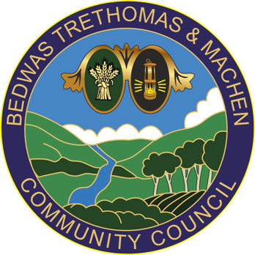
Bedwas, Trethomas & Machen Community Council
Council Offices
Newport Road
Bedwas
Caerphilly
CF83 8YB
Tel: (029) 2088 5734
E-mail: clerk@btmcc.co.uk

29th December 2021

To: All Councillors of Bedwas, Trethomas & Machen Community Council

You are summoned to attend the ‘ORDINARY MEETING’ via Microsoft Teams on Thursday 6th January 2022 at 6:30pm. The MS Teams link to follow.

If you are unable to attend this meeting, please send your apologies to clerk@btmcc.co.uk or telephone (029) 20885734 prior to the meeting.

In line with legislation, community council meetings are open to members of the public and press to attend.
Please contact BTM Council Offices in advance to request joining instructions.
Members of the press and public can attend on an observation basis only and
are not permitted to speak during the meeting.

The business to be transacted is set out in the agenda below. If any member requires further information on any item, please contact BTM Council Offices prior to the meeting.

Yours sincerely,

Ann Birkinshaw
Clerk to BTM CC

Full Council Meeting
AGENDA

- Police & Community Safety Matters

- To Receive and Note Declarations of Interest - Code of Conduct
Councillors are reminded of their personal responsibility to declare any personal and/or prejudicial interest(s) in respect of any item of business on this agenda in accordance with the Local Government Act 2000, the Community Councils Standing Orders and the Code of Conduct. If a councillor has a prejudicial interest, they must, unless a dispensation been granted, withdraw from the meeting and take no part in the discussion or vote.

- To note Member attendance and to receive and agree apologies for absence

- To consider, and if correct, arrange for the Chair to sign the minutes of the Ordinary Full Council Meeting held on 2nd December 2021 to confirm true and accurate records

- Matters arising from that meeting
Cllr Phipps wishes to discuss further Item 762 from the November meeting

- Clerk’s Report

- Finance Matters
7.1 To note and approve the reconciliation to bank as at 29th December 2021
7.2 To note and approve December bank payments
7.3 Financial assistance requests. One request received this month from Gwent WI

- Events & Leisure (EL) Committee
  - To receive a verbal update on the Christmas Family Panto which took place on 12th December at BWH and to note the date of the next meeting

- Finance, Employment & Policies (FEP) Committee
  - To discuss and agree the Precept for submission to CCBC by 31st Jan
  - A verbal update/report is expected and to note the date of the next Meeting

- Environment & CIL (ECIL) Committee
10.1 A verbal update/report is expected and to note the date of the next Meeting

- Land & Buildings Management (LBM) Committee
  - To discuss quotations received for the replacement of the stair carpet and kitchen flooring at the council offices and to note the date of the next meeting

- To note an updated Meeting and Events Schedule

- Correspondence items for discussion by Council

- Youth Representatives report

- Planning Applications
To consider the following Caerphilly County Borough’s planning applications in the Bedwas, Trethomas and Machen area received since the last full council meeting and the Community Council’s response to those planning applications. Any comments or enquiries to be emailed to: planning@caerphilly.gov.uk within 21 days of receipt of the email date. Late applications may be submitted at the meeting

Case Ref. 21/1074/COU Site Area: 4890m²
Location: Sutherland Trading Company Ltd Unit 3 Greenway Bedwas House Industrial Estate Bedwas Caerphilly CF83 8XQ (UPRN 000043164922)
Proposal: Subdivide and extend existing building to create 8 additional units (5 x class B1 use units and 3 x class A3 use units)
Case Officer: Anthony Pyne  01443 864523 pynea@caerphilly.gov.uk
Map Ref: 316466 (E) 188735 (N)
Decision Level: Delegated

- Exempt items

- Date of next meeting
Is scheduled for Thursday 3rd February 2022 at 6.30pm via the MS teams platform or in person indoors if allowed by Welsh Government

Meetings and events schedule
